**Demonstration speech definition**

As the name implies, demonstration speech is a speech devoted to teaching the audience how to do a particular thing. It is a clear, step-by-step practical guide which intends to show people methods of using regular items and even improve someone’s life with it. Demonstration speeches exist in different forms: they can be lengthy and detailed, short and straightforward, or medium and accurate. But either way, the very essence of this task is to teach you how to put thoughts into one, well-structured, and logical sequence of steps. It might seem dubious to take such a specific assignment, but if you take time to explore all the nuances and requirements for this task, it’ll be much easier to handle it eventually.

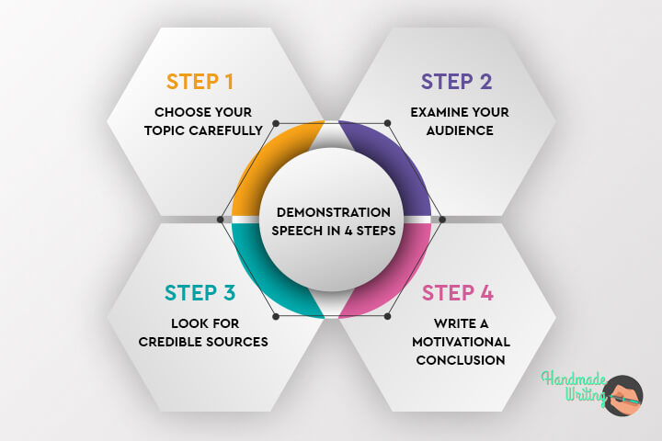

### Choose Your Topic Carefully

Like with any other essay type, demonstration speech starts with topic selection. You have a vast field of “how to” speech ideas to talk about, but the ultimate choice is always on you. Also, professors often tend to give a specific topic to their students. In cases like this, it’s even easier. Regardless of what your final topic is, there’s always a need for research. Once the topic is defined, and you’re 100 percent confident that it’s going to fit the timeframe for delivery, go on to the next step, which is the audience analysis.

### Examine Your Audience

There are specific criteria which can help you study the audience prior to delivering a speech. These factors include age, occupation, preferences, interests, and so on. So for example, if your listeners are professional gardeners, they’ll probably expect some useful advice on their sphere of interest. Instead of nurturing them with something as banal as “How to grow a plant,” give them real information, like “How to grow and take care of palm Washingtonia.” Likewise, if your audience composes of teenagers, speak about something thought-provoking, yet not too professional and dull. Take, for instance, the topic on how to become successful, or how to deal with depression.

### Look for Credible Sources

Before writing the demonstration speech, you’ll first need some assistance to prove the credibility of your sayings. If you don’t want the audience to think like the entire speech is a fly of your imagination, you should arm yourself with relevant evidence to prove the mentioned points. There are many places you can go to, like local libraries. They contain countless books on your topic, so you can use them for your advantage. Alternatively, consider using online resources, but only credible ones if you don’t feel like walking anywhere. Even if such assistance is not enough for you, ask relatives or friends for help. Some of them might be experts in your topic, and more than willing to explain how this or that thing works.

### Write a Motivational Conclusion

The best way to finish your demonstration speech is to give your audience a great insight into the process they haven’t experienced themselves. For this, you can call listeners to action and motivate them to follow your practice. Let’s review an example of a proper ending: “Now that you’ve learned about the basics of DIY table creation, you can craft one easily by yourself without costly materials and mountains of time.” Such a prominent calling will make people not only have a positive impression of your speech but also encourage them to make something useful.

## Demonstration speech outline

An outline is a way to structure the information that you want to share with your audience. The outline should explicitly showcase the order of steps that you will use in your demonstration speech. Many students seem to neglect the power of creating outlines for their academic writing tasks, but in vain. The key feature that makes outlines as significant as other processes of speech creation is a schematic representation of the main ideas. It means that writing the final variant of your demonstration speech will be much easier as you have an exact plan, and you don’t need to think of the main points on the fly. As for the structure of an outline, it should contain the following elements:

* three sections – introduction, main body, and conclusion.
* the main part should be broken up into different stages of the process.
* headings and subheadings marked with letters and numbers for easier navigation throughout the outline

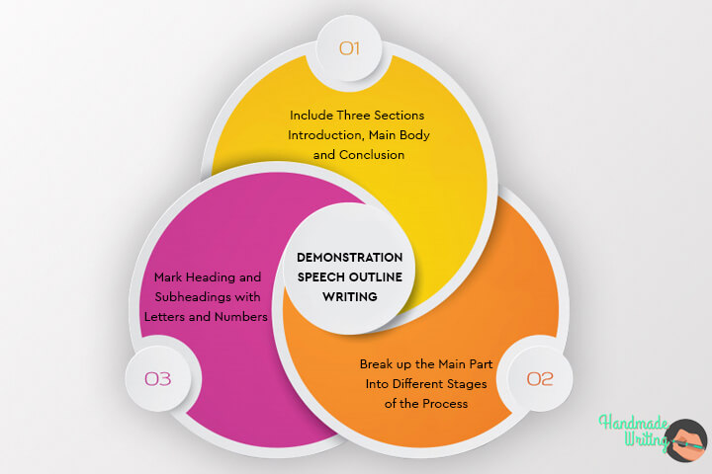

At the phase of plan creation, it’s also vital to adhere to theses and use them as reference points. These can be either sentences or just keywords. Do as you are accustomed to doing and feel comfortable with making amendments before proceeding with writing the speech text. For each statement, use examples from personal life to validate the adequacy of described steps. Vast reasoning is, of course, excellent, but without specifics, they do not cling. To find the response in the heart of the audience, make your how-to-do instructions more understandable. For example, if you want to explain to your audience how to make and install a wall-mounted folding table, don’t just enumerate the instruments required and tell people how to fold and unfold the table. Rather, give them proper instructions.

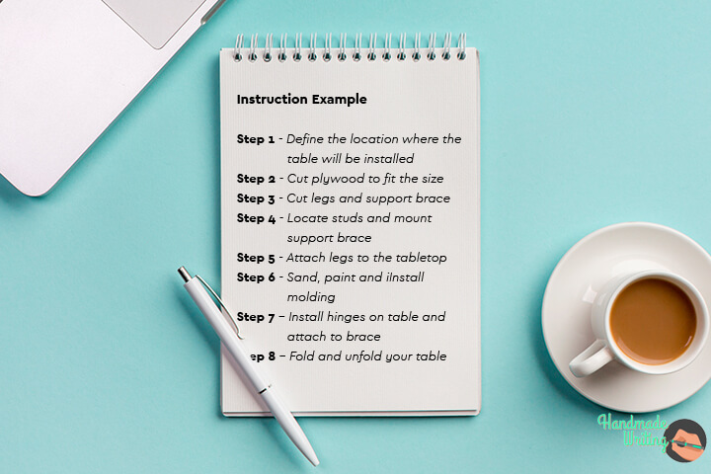

**DEMONSTRATIVE SPEECHES IN COMPUTER SCIENCE**

Demonstrative speeches are speeches in which the aim of the speaker is to demonstrate

* A process
* How an activity/task is done
* How to use a given object or a thing

For projects given in different courses, students are required to give a demonstrative speech (Also called a presentation without a slide show) in front of the teachers. Following steps are involved in planning a demonstrative speech:

1. Determine the speech purpose: The first most important thing is to understand your aim behind speaking. Usually, there can be two major aims: TO INFORM and TO PERSUADE.
2. Analyze audience: Remember that your audience will be lecturers, professors, or clients.
3. Context analysis: The situation and domain of communication will be formal.
4. Planning your speech: First brainstorm, and jot down all the steps involved in a process, all the steps one needs to follow when performing a task, and all the key instructions and guidelines about how to use something. The idea is to break down the subject into many parts. Explain each part separately.
5. Organizing information: Organize everything into a clear pattern which will naturally lead to the completion of the task or process.
6. Visual aid: Use charts, videos, objects, or anything else that can help you demonstrate and explain everything effectively.

For example, in a demonstrative speech on the project “Developing a Game”, your teacher will expect you to achieve the following objectives and address the given issues:

* To inform about the game
* Explain why you chose this type of a game.
* To demonstrate how the game will be used/ operated?
* What are the different functions?
* How can these functions be performed? You will have to give a demo and explain.
* What techniques (algorithms) did you use and why? Justify your choices.
* How can your game serve the society?
* What type of impact will your game have on the human personality and psychology?
* What are the future implications of your game?
* Where do you see it in the future?

In your speech, you will carry out two goals: Inform with demo and persuade the teacher in favor of your choices and vision. You can address each question one by one in an organized fashion. Same questions and issues are to be addressed in other such projects as well.